

JOWAVES — RIDER 2026
TECHNICAL · HOSPITALITY · TRANSFERS

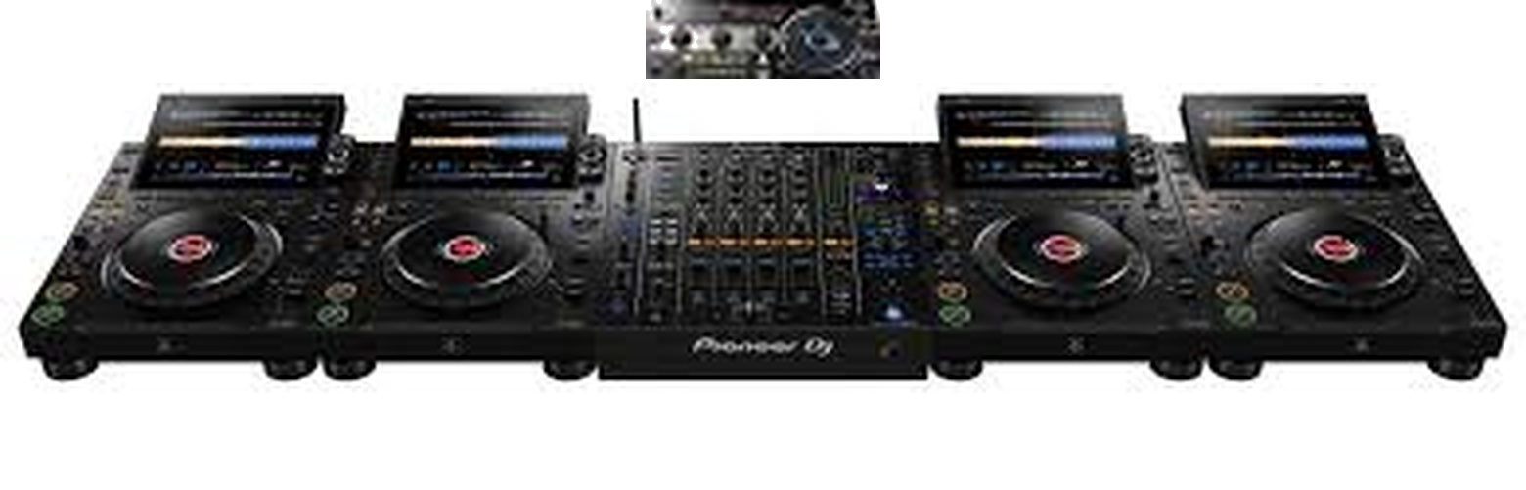
— TECHNICAL RIDER

PA SYSTEM — ONLY PREMIUM BRANDS
Use only premium brands such as L-Acoustics, Void, Funktion One, or d&b audiotechnik.
DJ BOOTH — REQUIRED EQUIPMENT
· 4× Pioneer CDJ-3000X (preferred) or CDJ-3000 — strictly Pioneer, all units linked via LAN. Minimum 3, 4 preferred.
· 1× Pioneer DJM-A9 — strictly DJM-A9 only.
· 1× Pioneer RMX-1000 — placed on a stand in front of the mixer for live effects.
· The warm-up DJ must play strictly in USB mode — no laptop / DJ software allowed during warm-up.
SOUND SYSTEM
· Monitors — 2× high-fidelity monitors (L-Acoustics, Void, Funktion One, or d&b audiotechnik).
· Subwoofers — 2× double 18" high-fidelity subs (same brands).
SETUP & SOUND CHECK
Internal sound system and stage equipment must be set up and ready before sound check. In-house sound and light technicians must be present.

— HOSPITALITY RIDER

ACCOMMODATION
5-star hotel including: gym, high-speed internet, spa with therapeutic massage, and barber service.
CATERING
IMPORTANT: all food must be vegetarian — dairy OK, no meat, no fish.
· 1× bottle of Grey Goose or Belvedere vodka (1.75 L).
· 6× Red Bull Zero Sugar · 6× Coke Zero · 6× Schweppes Lemon Zero.
· 6× bottles of water · 6× bottles of coconut water.
· 1× large fruit platter — grapes, mango, pineapple, watermelon.
TRANSFERS
· Luxury car only — no public transport allowed. Airport transfers required.

