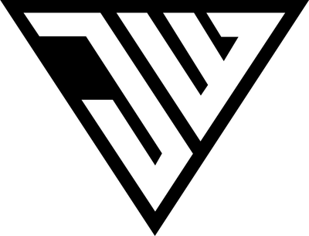
JOWAVES — BIO 2026
DJ · PRODUCER · MUSIC DIRECTOR · VENUE FOUNDER

— LONG VERSION
For press releases, features, and full bio sections
French-Canadian by origin and Asia-based by choice, JoWaves is one of the fastest-rising DJs in today's electronic scene. After stepping back behind the decks in 2022, he has compressed a typical career arc into three years — from a comeback set to Tomorrowland, Ultra Europe, and the music direction of one of the world's top 100 clubs.
In 2026, he is performing for his third consecutive season at Ultra Music Festival Croatia on the UMF Stage, and is confirmed for both Tomorrowland Winter 2026 and Tomorrowland Thailand 2026 (announcement TBA). A Tomorrowland Academy certified DJ, he has shared decks at top-ranked venues across the globe, including Shôko Barcelona (#7 best club in the world), Noa Beach Club Croatia (#10 DJ Mag Top 100 Clubs 2025), and O Beach Ibiza this summer.
His Asian residency runs deep: he is the Music Director of Republic Club Pattaya, where in less than six months under his direction the venue entered the DJ Mag Top 100 for the first time — debuting at #90 in 2025 and climbing to #82 worldwide in 2026. In parallel, he is co-developing the Republic Phuket complex on Bangla Road, with Republic opening in December 2026 and Drip and Tulum following in 2027.
Beyond the festival circuit, JoWaves is the official DJ for AYO & TÉO, whose hit “Rolex” surpassed one billion YouTube streams. His sound moves between bass house, tech house, and melodic electronic — built for clubs and festivals alike. He has performed at major international events including Invasion Festival Myanmar (presented by Heineken), Thingyan Water Festival Yangon (presented by Red Bull), and at venues across France, Spain, Croatia, Thailand, and Southeast Asia.
With a verified Instagram audience of 163K followers and over 1.1 million monthly views, JoWaves continues to expand his footprint through high-profile festivals, club residencies, and global bookings.

— SHORT VERSION
For booking inquiries, social media, and lineup announcements (~80 words)
French-Canadian, Asia-based. JoWaves is the Music Director of Republic Club Pattaya (#82 DJ Mag Top 100 2026), confirmed for Tomorrowland Winter 2026 and his third consecutive season at Ultra Music Festival Croatia. He has performed at Shôko Barcelona (#7 best club in the world), Noa Beach Club Croatia (#10 DJ Mag), and O Beach Ibiza. Official DJ for AYO & TÉO (“Rolex” — 1B+ streams). His sound spans bass house, tech house, and melodic — built for clubs and festivals.

— ONE-LINER
For lineup posters, social tags, and quick mentions
JoWaves — Music Director of Republic Club Pattaya (#82 DJ Mag) · Tomorrowland Winter 2026 · Ultra Music Festival Croatia ×3 · Shôko Barcelona · Noa Beach Club · O Beach Ibiza.

